- Range Partitioning
-- Create table with RANGE partitioning on sales_date
CREATE TABLE sales1
(
customer_id NUMBER,
sales_date DATE,
order_amount NUMBER,
region NVARCHAR2(10)
)
PARTITION BY RANGE (sales_date)
(
PARTITION p1 VALUES LESS THAN (TO_DATE('01-03-2015', 'DD-MM-YYYY')),
PARTITION p2 VALUES LESS THAN (TO_DATE('01-05-2015', 'DD-MM-YYYY')),
PARTITION p3 VALUES LESS THAN (TO_DATE('01-07-2015', 'DD-MM-YYYY')),
PARTITION p4 VALUES LESS THAN (MAXVALUE)
);
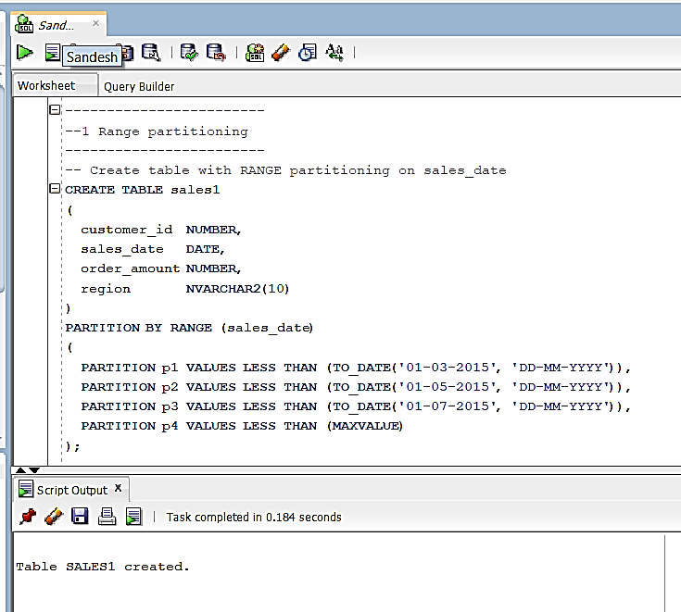

-- Insert rows (
-- p1 (date < 01-03-2015) -> 1 row
INSERT INTO sales1 (customer_id, sales_date, order_amount, region)
VALUES (1, TO_DATE('01-01-2015', 'DD-MM-YYYY'), 600, N'SOUTH');

-- p2 (>=01-03-2015 and <01-05-2015) -> 2 rows
INSERT INTO sales1 (customer_id, sales_date, order_amount, region)
VALUES (2, TO_DATE('15-03-2015', 'DD-MM-YYYY'), 1200, N'NORTH');

INSERT INTO sales1 (customer_id, sales_date, order_amount, region)
VALUES (3, TO_DATE('30-04-2015', 'DD-MM-YYYY'), 750, N'EAST');

-- p3 (>=01-05-2015 and <01-07-2015) -> 3 rows
INSERT INTO sales1 (customer_id, sales_date, order_amount, region)
VALUES (4, TO_DATE('05-05-2015', 'DD-MM-YYYY'), 300, N'WEST');

INSERT INTO sales1 (customer_id, sales_date, order_amount, region)
VALUES (5, TO_DATE('20-05-2015', 'DD-MM-YYYY'), 450, N'SOUTH');

INSERT INTO sales1 (customer_id, sales_date, order_amount, region)
VALUES (6, TO_DATE('15-06-2015', 'DD-MM-YYYY'), 900, N'NORTH');

COMMIT;
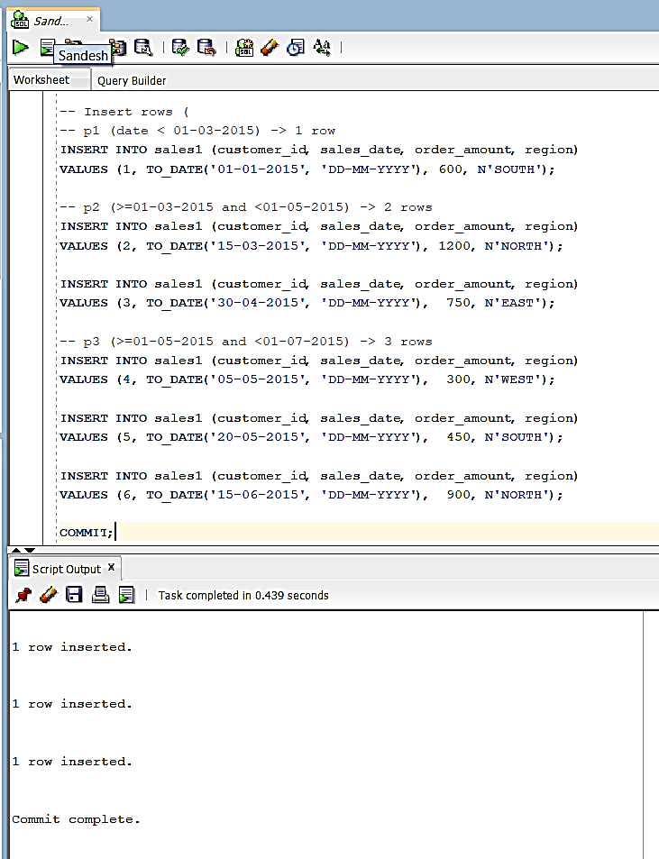

-- Verify: view all rows
SELECT * FROM sales1 ORDER BY sales_date;
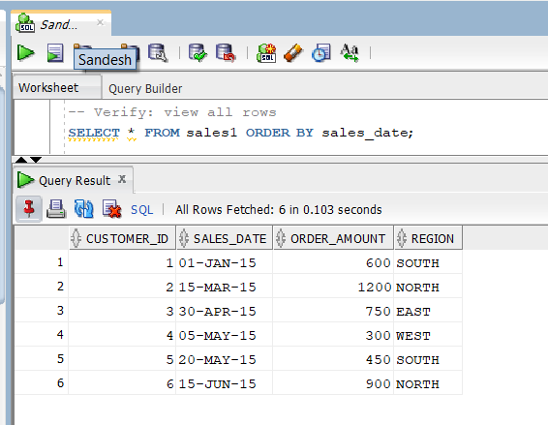
--view partitioned value
SELECT * FROM sales1 PARTITION (p3);
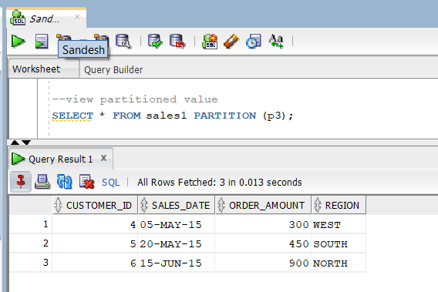

- List partitioning
-- Create table partitioned by LIST on region (
CREATE TABLE sales2
(
customer_id NUMBER,
sales_date DATE,
order_amount NUMBER,
region NVARCHAR2(10)
)
PARTITION BY LIST (region)
(
PARTITION p1 VALUES ('East'),
PARTITION p2 VALUES ('West'),
PARTITION p3 VALUES ('North'),
PARTITION p4 VALUES ('South')
);
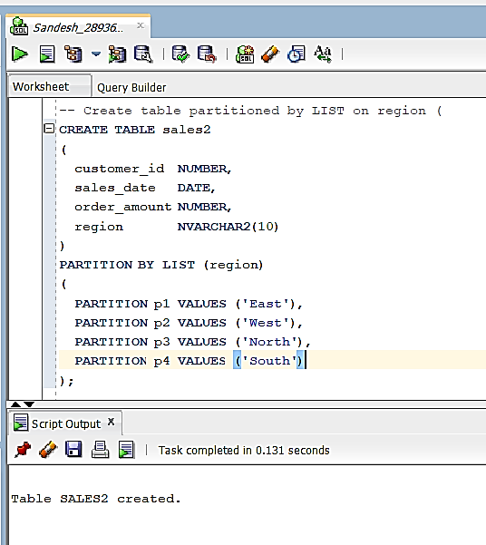

--insert into list partitioning
INSERT INTO sales2 (customer_id, sales_date, order_amount, region)
VALUES (110, TO_DATE('01-FEB-2015','DD-MON-YYYY'), 200, N'East');

INSERT INTO sales2 (customer_id, sales_date, order_amount, region)
VALUES (111, TO_DATE('12-FEB-2015','DD-MON-YYYY'), 350, N'East');
INSERT INTO sales2 (customer_id, sales_date, order_amount, region)
VALUES (112, TO_DATE('25-FEB-2015','DD-MON-YYYY'), 150, N'East');

INSERT INTO sales2 (customer_id, sales_date, order_amount, region)
VALUES (120, TO_DATE('05-MAR-2015','DD-MON-YYYY'), 400, N'West');
INSERT INTO sales2 (customer_id, sales_date, order_amount, region)
VALUES (121, TO_DATE('20-MAR-2015','DD-MON-YYYY'), 250, N'West');

INSERT INTO sales2 (customer_id, sales_date, order_amount, region)
VALUES (130, TO_DATE('03-APR-2015','DD-MON-YYYY'), 500, N'North');
INSERT INTO sales2 (customer_id, sales_date, order_amount, region)
VALUES (131, TO_DATE('15-APR-2015','DD-MON-YYYY'), 275, N'North');
INSERT INTO sales2 (customer_id, sales_date, order_amount, region)
VALUES (132, TO_DATE('29-APR-2015','DD-MON-YYYY'), 325, N'North');

INSERT INTO sales2 (customer_id, sales_date, order_amount, region)
VALUES (140, TO_DATE('07-MAY-2015','DD-MON-YYYY'), 180, N'South');
INSERT INTO sales2 (customer_id, sales_date, order_amount, region)
VALUES (141, TO_DATE('21-MAY-2015','DD-MON-YYYY'), 420, N'South');
COMMIT;
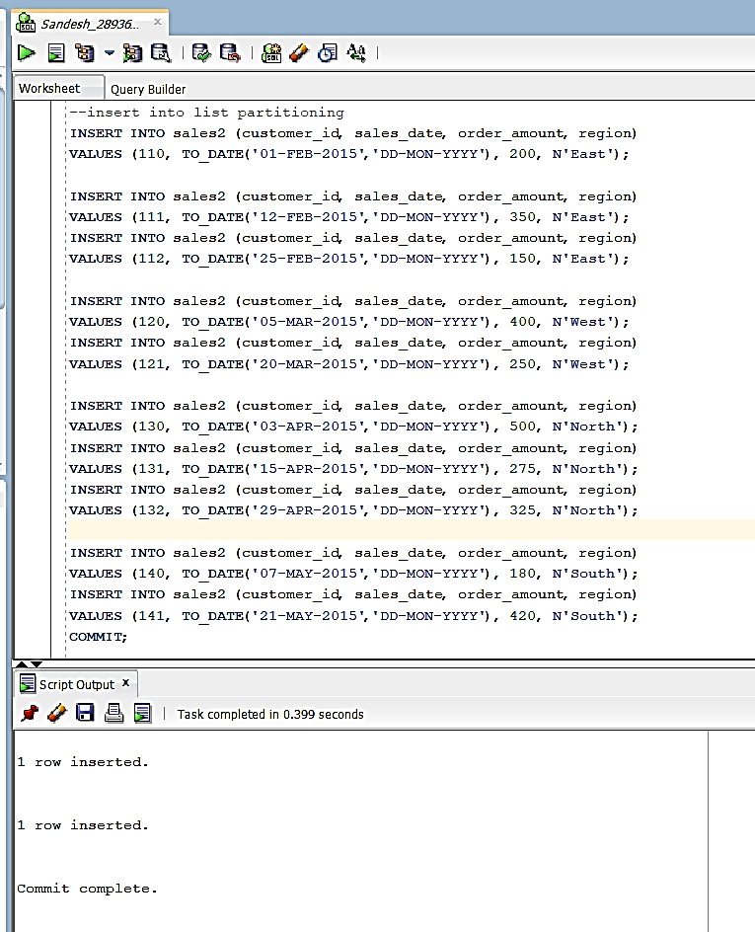

-- Verify: view all rows ordered by region/date
SELECT * FROM sales2 ORDER BY region, sales_date;
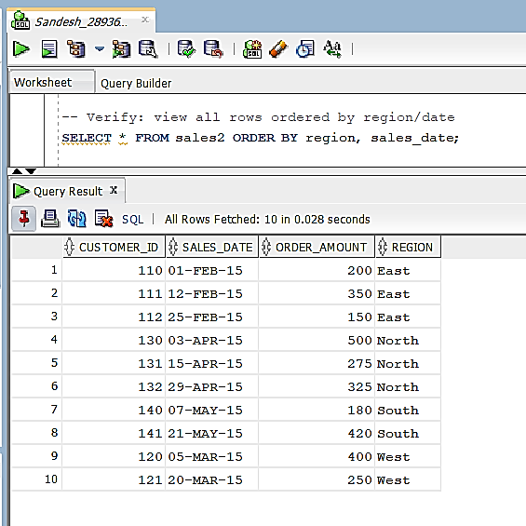

--view partitioned value
SELECT * FROM sales2 PARTITION (p1);
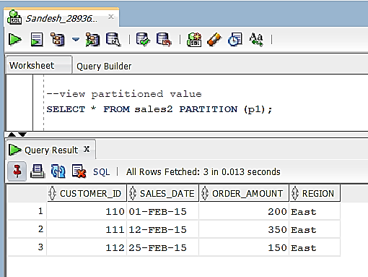

- Hash Partitioning
-- Create table with HASH partitioning and named partitions so PARTITION(...) selects work
CREATE TABLE sales3
(
customer_id NUMBER,
sales_date DATE,
order_amount NUMBER,
region NVARCHAR2(10)
)
PARTITION BY HASH (customer_id)
(
PARTITION p1,
PARTITION p2,
PARTITION p3,
PARTITION p4
);
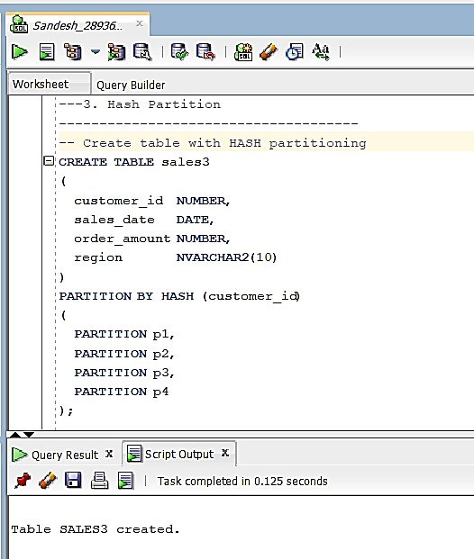
--insert values for hash partitioning
INSERT INTO sales3 (customer_id, sales_date, order_amount, region)
VALUES (11, TO_DATE('01-FEB-2015','DD-MON-YYYY'), 1200, N'West');

INSERT INTO sales3 (customer_id, sales_date, order_amount, region)
VALUES (12, TO_DATE('10-FEB-2015','DD-MON-YYYY'), 450, N'East');

INSERT INTO sales3 (customer_id, sales_date, order_amount, region)
VALUES (13, TO_DATE('20-FEB-2015','DD-MON-YYYY'), 800, N'South');

INSERT INTO sales3 (customer_id, sales_date, order_amount, region)
VALUES (14, TO_DATE('28-FEB-2015','DD-MON-YYYY'), 300, N'North');

COMMIT;
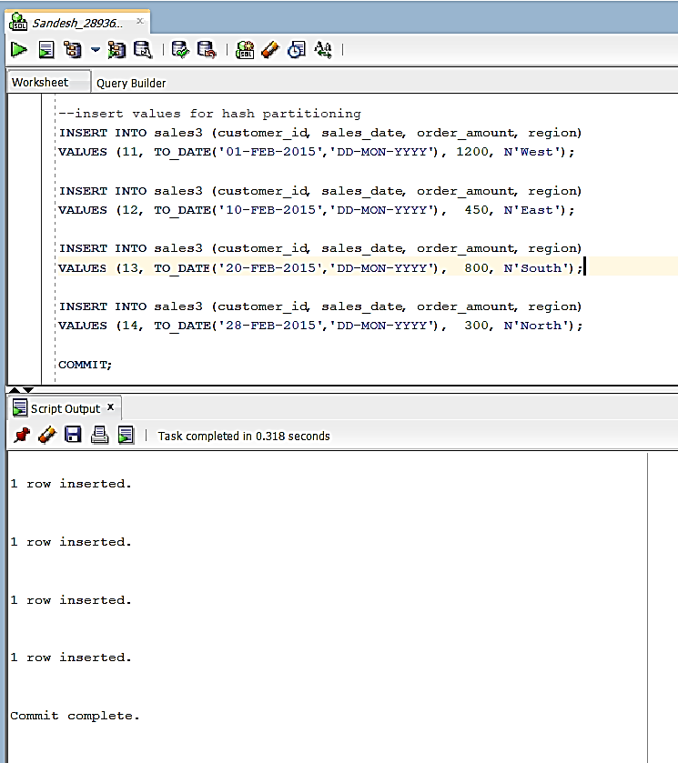

-- Verify: view all rows
SELECT * FROM sales3 ORDER BY customer_id;
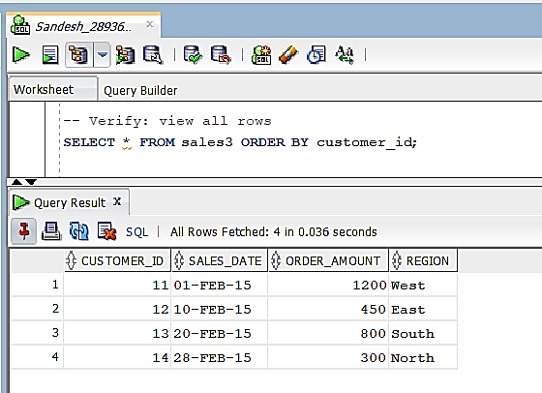

--view from partition
SELECT * FROM sales3 PARTITION (p2) ORDER BY customer_id;
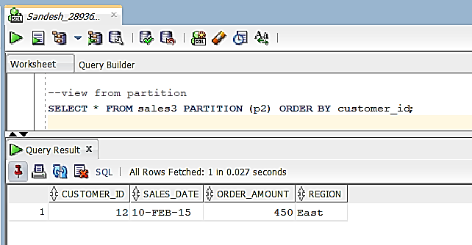

- Composite Partitioning
CREATE TABLE sales4
(
customer_id NUMBER,
sales_date DATE,
order_amount NUMBER,
region NVARCHAR2(10)
)
PARTITION BY RANGE (sales_date)
SUBPARTITION BY HASH (customer_id) SUBPARTITIONS 4
(
PARTITION p1 VALUES LESS THAN (TO_DATE('01-03-2015','DD-MM-YYYY')),
PARTITION p2 VALUES LESS THAN (TO_DATE('01-05-2015','DD-MM-YYYY')),
PARTITION p3 VALUES LESS THAN (TO_DATE('01-07-2015','DD-MM-YYYY')),
PARTITION p4 VALUES LESS THAN (MAXVALUE)
);
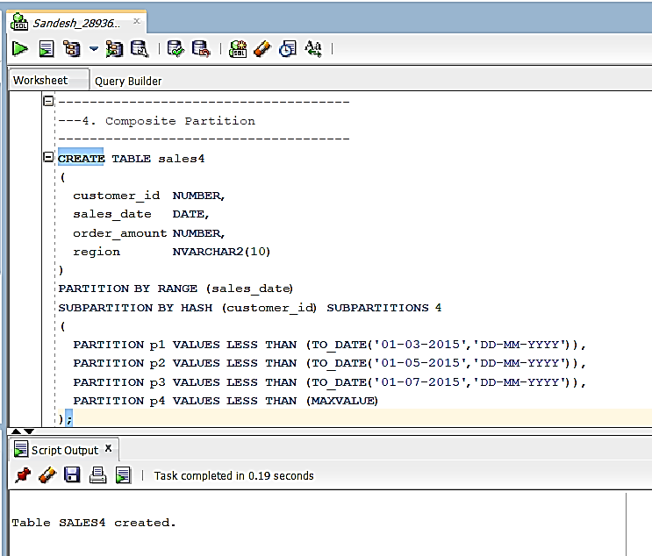
-- Inserts to composite table
-- p1 (date < 01-03-2015) -> 1 row
INSERT INTO sales4 (customer_id, sales_date, order_amount, region)
VALUES (1, TO_DATE('15-01-2015','DD-MM-YYYY'), 500, N'East');

-- p2 (>=01-03-2015 and <01-05-2015) -> 2 rows
INSERT INTO sales4 (customer_id, sales_date, order_amount, region)
VALUES (2, TO_DATE('20-03-2015','DD-MM-YYYY'), 1200, N'West');

INSERT INTO sales4 (customer_id, sales_date, order_amount, region)
VALUES (3, TO_DATE('10-04-2015','DD-MM-YYYY'), 750, N'North');

-- p3 (>=01-05-2015 and <01-07-2015) -> 2 rows
INSERT INTO sales4 (customer_id, sales_date, order_amount, region)
VALUES (4, TO_DATE('05-05-2015','DD-MM-YYYY'), 300, N'South');

INSERT INTO sales4 (customer_id, sales_date, order_amount, region)
VALUES (5, TO_DATE('15-06-2015','DD-MM-YYYY'), 900, N'East');

-- p4 (MAXVALUE) -> 1 row (example from your original)
INSERT INTO sales4 (customer_id, sales_date, order_amount, region)
VALUES (111, TO_DATE('02-07-2015','DD-MM-YYYY'), 2100, N'East');

COMMIT;
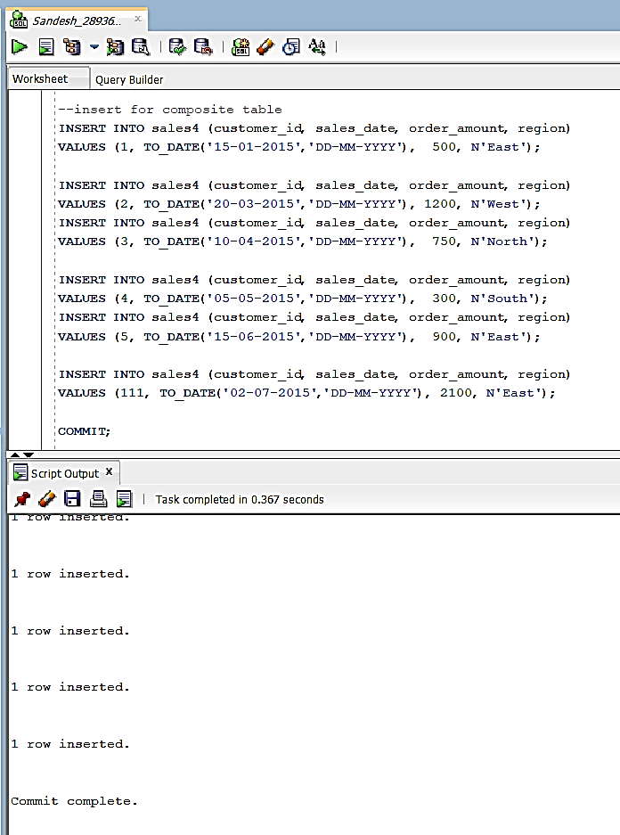

-- Verify: view all rows ordered by date
SELECT * FROM sales4 ORDER BY sales_date;
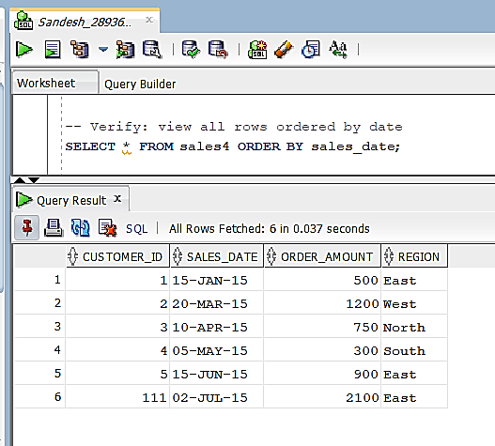

-- 1) Show existing partitions (Oracle dictionary)
SELECT partition_name, high_value
FROM user_tab_partitions
WHERE table_name = 'SALES1'
ORDER BY partition_position;
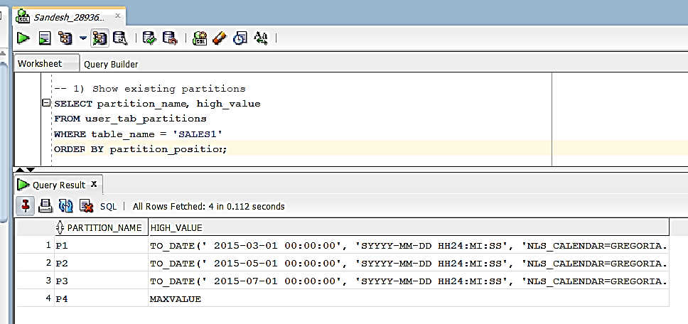

-- 2) Drop partition p2
ALTER TABLE sales1
DROP PARTITION p2;
